**Memorandum**

**To:** John Doe

**From:** Caleb Groves and Jack Casdorph

**Date:** 10/13/2017

**Subject:** Accuracy of image-based particle tracking using a 1-camera (2D) method versus a 2-camera (3D) method.

**Introduction**

The 3D position of a particle or point can be tracked over time by capturing the movement of the particle with 2 video cameras. In considering how we (the team) will be able to consistently track the rigid body motion, the two methods we’ve decided to investigate are that of a one-camera video tracking method, and a two-camera video tracking method using Direct Linear Transformation to change the 2d images to three dimensional coordinates. Since both have possible pro’s and con’s, it will be a matter of making a weighted decision based on our needs and circumstances and how they compare to the quantitative comparisons we can achieve through this experiment.

If the motion of the particle is mostly planar, it is possible to accurately track its movement with just 1 camera. This method requires 2 things: (1) the movement of the particle must be completely planar, and (2) the plane of the camera must be perfectly parallel with the plane of motion. It is extremely unlikely that both of these conditions would exist in a real-world study, so it can be assumed that the 1-camera method will produce errors that could be avoided by using the 2 camera method.

The question is how large can we expect the errors of the 1-camera method to be? If they are small then its benefits of being easier, cheaper, and faster than the 2-camera method may outweigh its costs in accuracy loss. If the errors are large, however, then the 2 camera approach is most likely better.

**Methods**

In order to test the accuracy of the 1-camera motion capture method vs the 2-camera method, we decided to track a real-world planar motion using both methods. The motion that we chose to track was the motion of a ball connected to the shaft of a spinning motor. We can expect the path of that ball to be circular, and therefore planar.

To see how the angle of the plane of motion relative to the place of the camera affects the accuracy of the 1-camera method, we tracked the motion of the ball under 2 scenarios. In the first scenario, the plane of motion of the ball was nearly parallel to the plane of the camera. In the second scenario, there was an angle of about 45 degrees between the 2 planes.

The frame rate of each video capturing the motion of the ball was 30 fps. The motion of the ball was relatively slow, so we decided that looking at only every other frame would still accurately track the motion. A snapshot at every other frame meant that we had discrete positional data for the ball a an interval of .0667 seconds. The ball was painted bright green to make it stand out from the surrounding objects. Using a program to calculate the centroid of the area of green pixels in each sampled frame of each video, we were able to automatically determine the approximate pixel position at each discrete point in time.

For the 1-camera method, we found a simple, scalar calibration factor to convert the pixels in the picture into inches. We then and found and plotted the x and y position of the the ball (relative to the front, right corner of the calibration grid) for each point in time.

**Results**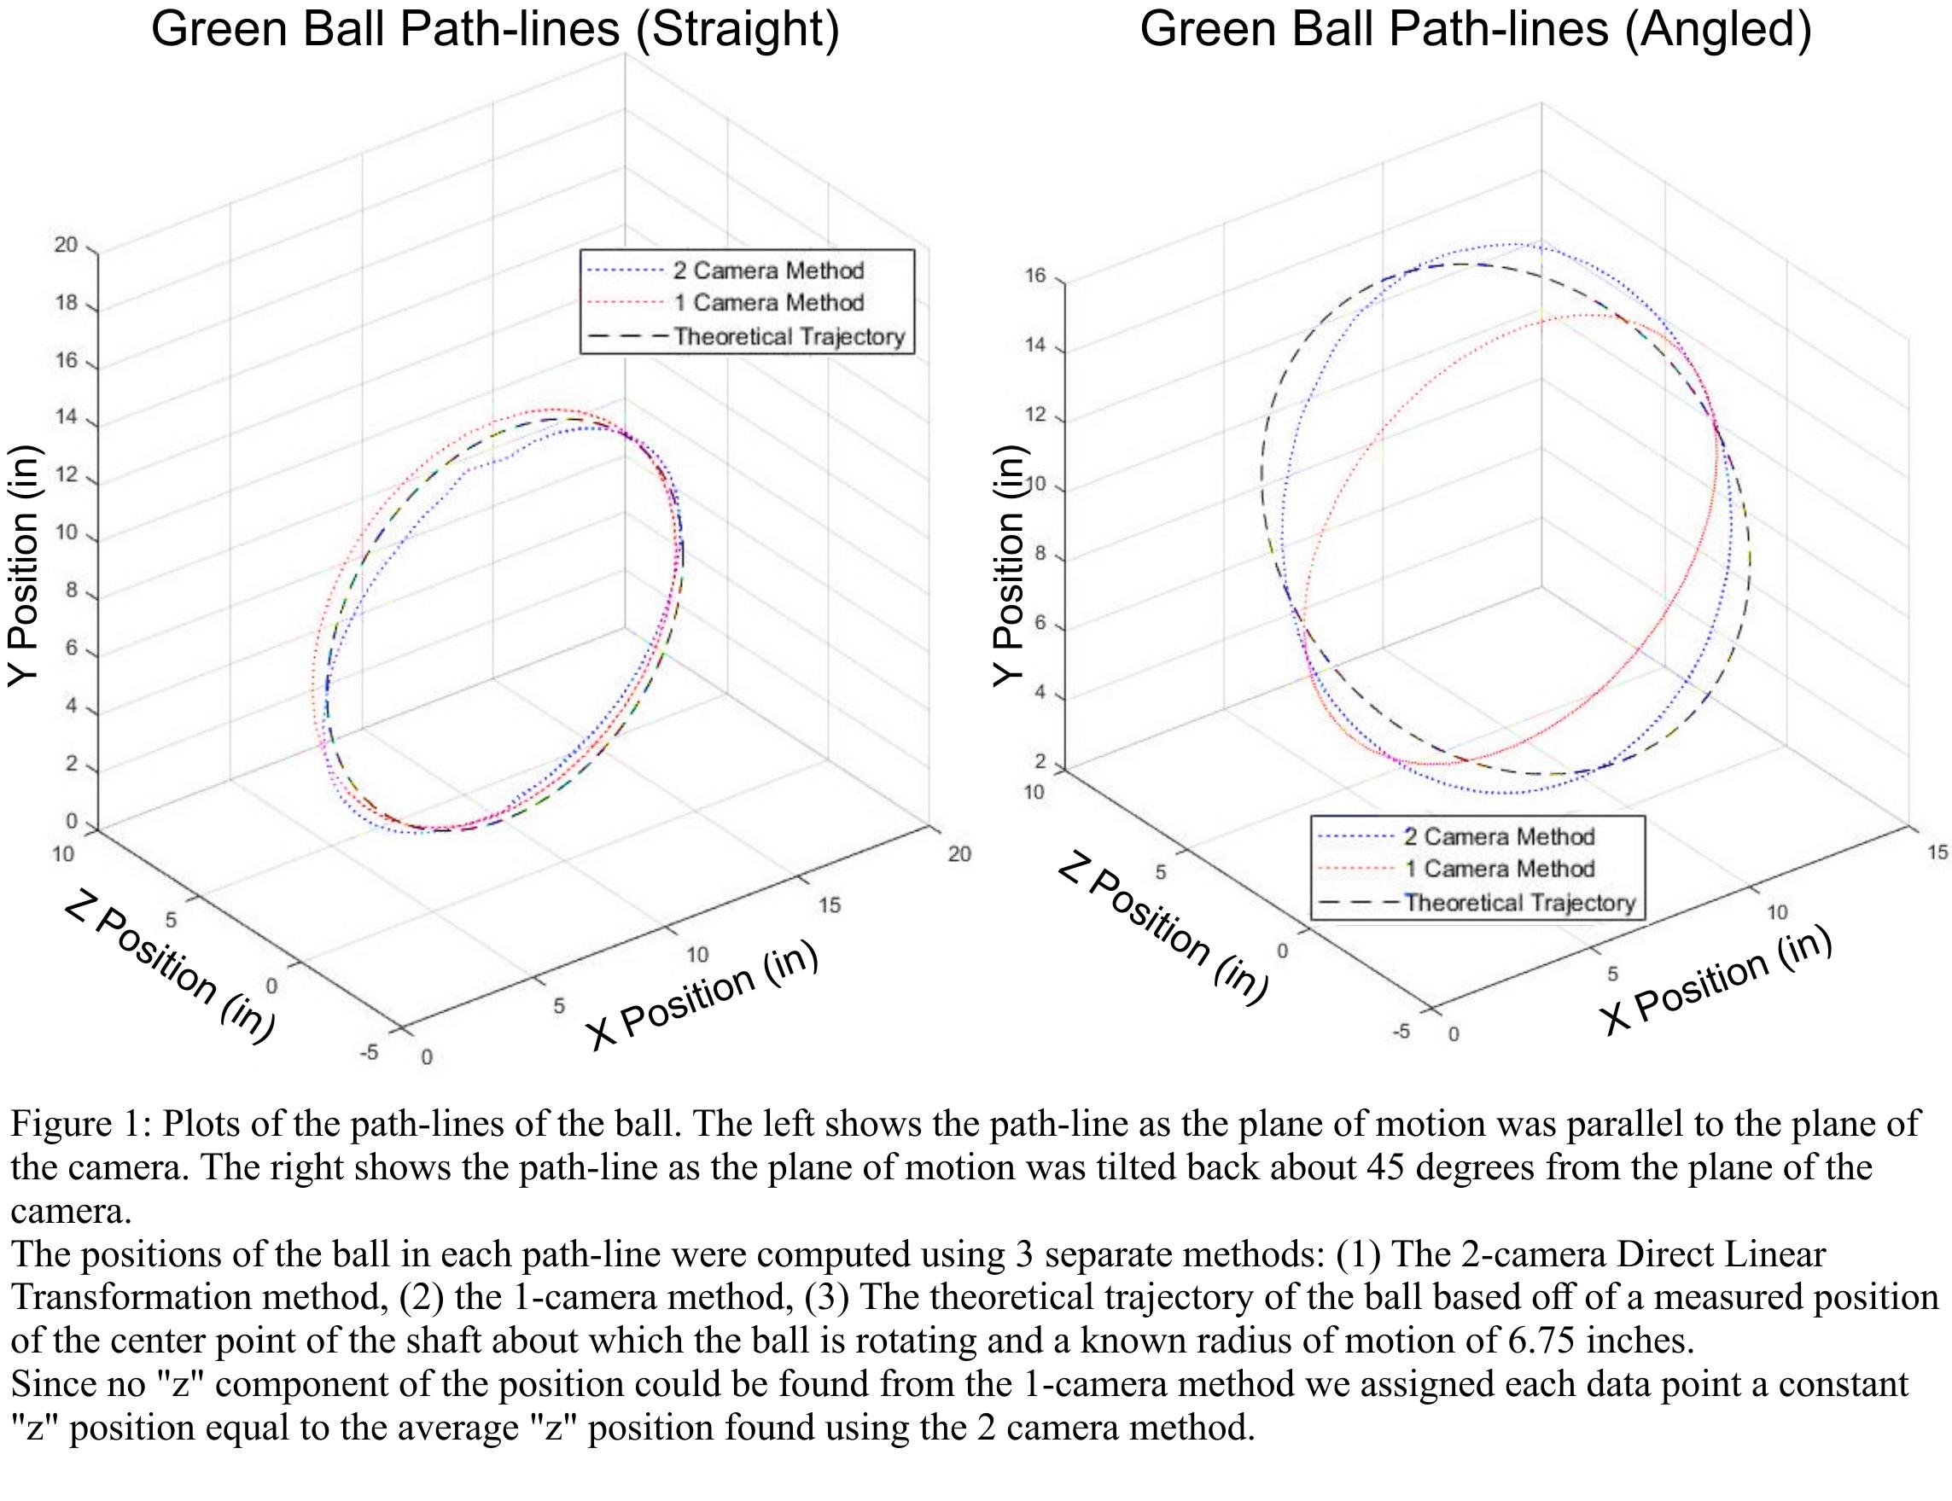

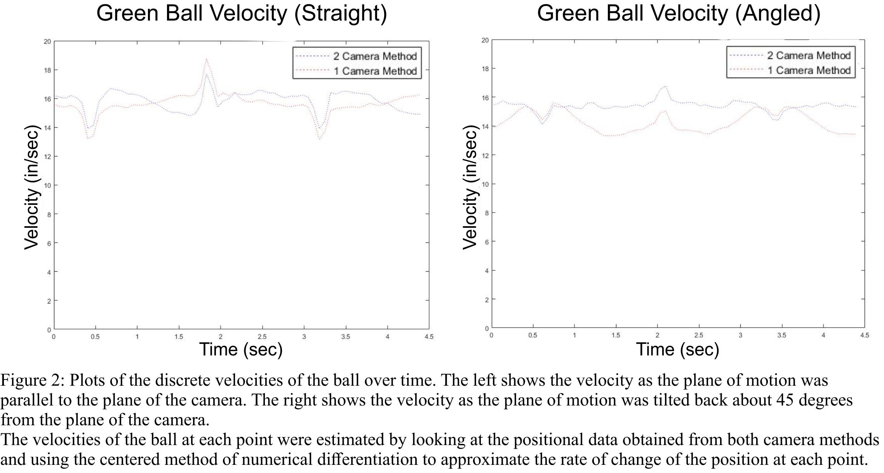

**Discussion**

We found that tracking planar motion with only one camera can be done fairly accurately as long as the plane of motion is parallel to the plane of the camera. In looking at the errors in the data between the 1 and 2-camera methods, we found that the error for both methods was roughly equal when the plane of motion was parallel to the plane of the camera. When the plane of motion was titled back 45 degrees, however, the error in the 1-camera method changed significantly, while the 2-camera error did not really change.

Both positional estimation methods had large errors when the ball was at the top or bottom of its rotation. These areas of error can be easily seen in the spikes and valleys of the plots of the velocity of the ball (Figure 2). The upper region of the rotation of the ball was outside of the calibration area, resulting in larger errors for the estimation of the position of the ball when the ball was in that region. In the lower extremes of the ball position, errors also intensified because the ball was getting close to the edge of the calibration area. These areas could have been avoided by ensuring that the calibration area was larger than the area of motion.